Environmental Variables:

Shell variables: Temporally use/available, they will not execute any script even defined any variable.

When we call shell variable with echo $ sign must write beginning of variable. (Ex: echo $My_var)

Environment variables: Permanently use/available (PATH, USER, HOME, EDITOR etc.)

* echo $SHELL or which bash: Give us which shell using
* cat /etc/shells: Give us other shells
* bash: Open new shell
* env: Display and manipulate the environment variables
* printenv “variable”: Value of a particular environment variable
* set: Set the value to the shell/environment variables
* unset: Unset the values of variable

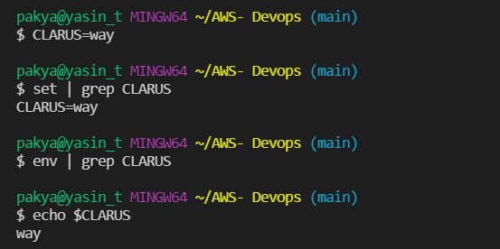

* Manipulation of Shell variable. If you open new shell, you can’t see it.
* export: Sets environment variables

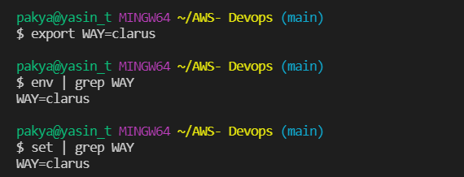

* Manipulation of environment variable. If you open new shell, you can see it.
* printenv PATH: Path variable use to find where executable files store
* Create **file.sh** inside of **new folder**. If we add folder to the end of path way, we can execute the **file.sh** script file.